TaskTrackr – Design Document
1. Project Overview
TaskTrackr is a task management web app inspired by Microsoft To Do. It helps users manage tasks, lists, daily work, and priorities. The inspiration comes from the limitations of the Microsoft to do which does not display My Day page/next days task appropriately. It will display tasks created for another day to my day as mentioned in the screenshot below. The ideas was to customize and have added functionality as per my requirement for my tasks management. Additionally, it does not give option to have add the priority for the tasks such as Low, Medium, High.

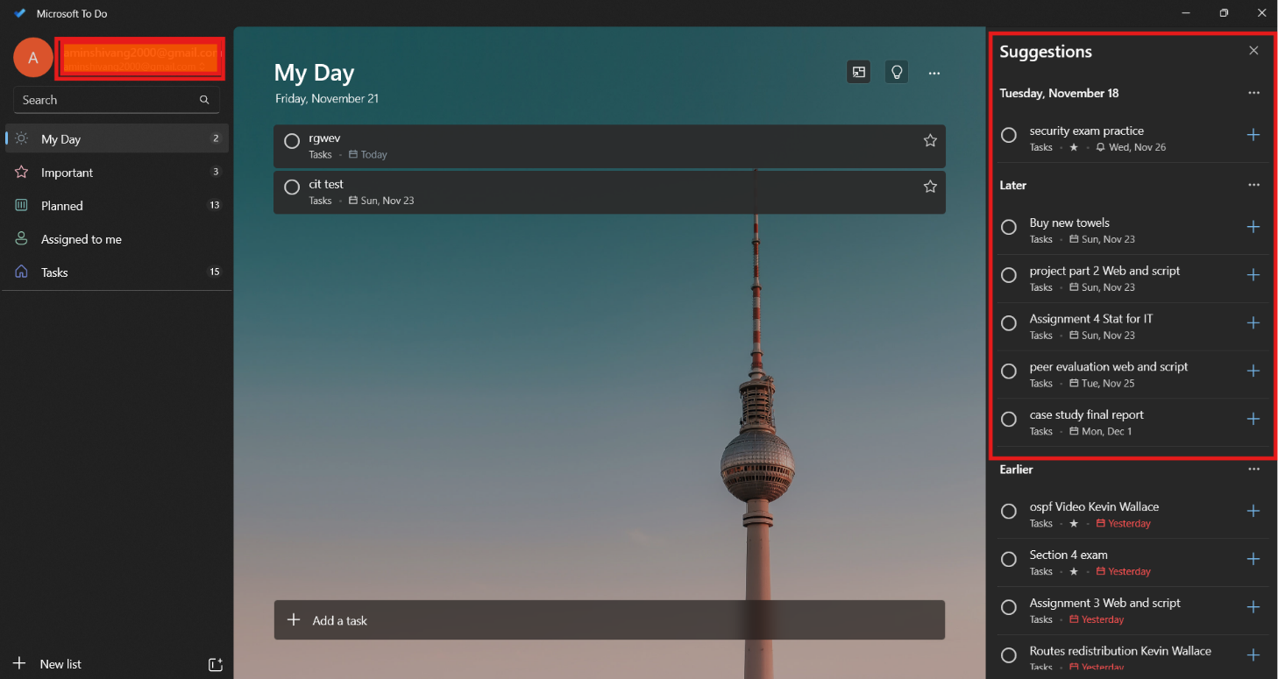

2. Target Users & Goals
Target users include students and professionals. The goal is to provide an easy, organized task manager with views such as My Day, Important, Priority, and custom lists.
3. Information Architecture
Main pages include My Day (/), All Tasks (/todos), Lists Overview (/lists), List View, and CRUD pages for tasks and lists.

4. Initial UI Design Plan
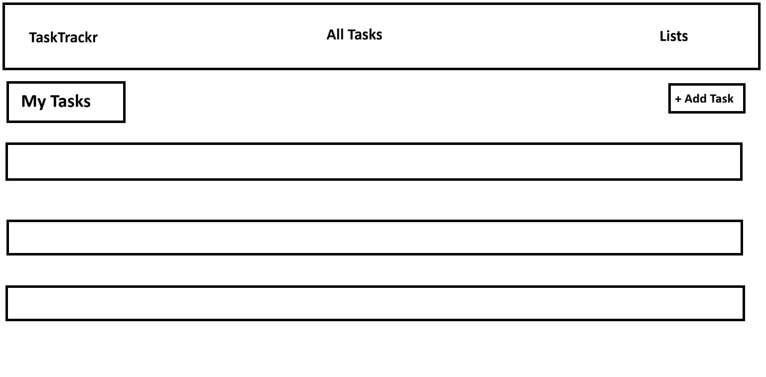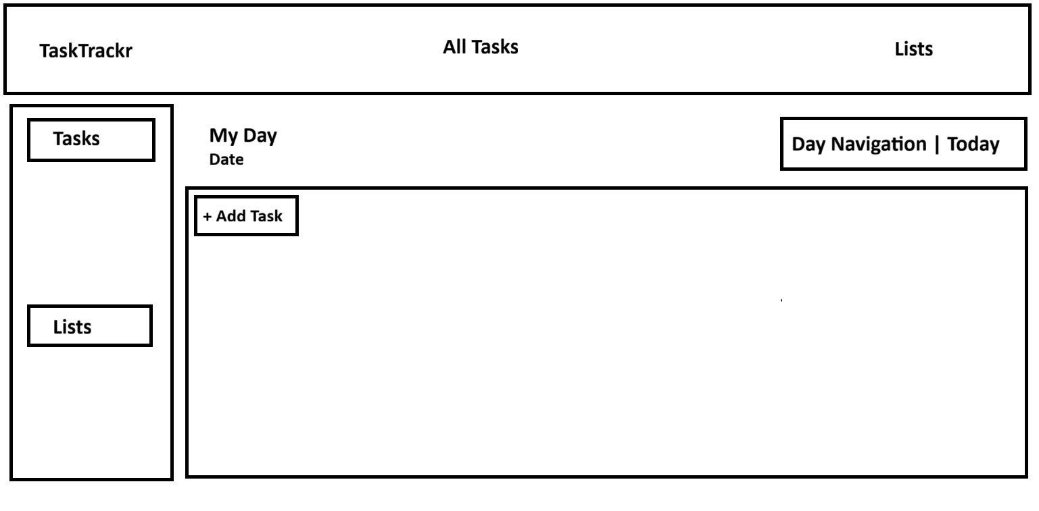
Includes a top navbar, left sidebar (My Day, Important, Planned, lists), and main content tables for tasks.

5. Data Design (Schemas)
Task schema: title, dueDate, priority, important, completed, list.
List schema: name, createdAt.

6. Interaction Flows
Covers adding tasks, completing tasks, showing/hiding completed items, date navigation, and list management.
7. Technology Stack
Node.js, Express.js, MongoDB Atlas, Mongoose, EJS, Bootstrap.
8. Non-Functional Requirements
Includes usability, performance, reliability, maintainability, user experience
9. Future Enhancements
Authentication, subtasks, reminders, drag‑and‑drop, search, dark mode, notifications.
Expected directory:
├── app.js
├── package.json
├── .env
├── /config
│ └── db.js
├── /models
│ ├── Todo.js
│ └── List.js
├── /routes
│ ├── todoRoutes.js
│ └── listRoutes.js
├── /views
│ ├── index.ejs # My Day (home)
│ ├── important.ejs
│ ├── planned.ejs
│ ├── /todos
│ │ ├── list.ejs
│ │ ├── new.ejs
│ │ ├── edit.ejs
│ │ └── delete.ejs
│ └── /lists
│ ├── index.ejs
│ ├── new.ejs
│ ├── show.ejs
│ └── delete.ejs
└── /public
└── /css
└── styles.css

